A

REPORT

ON

BASANTA UTSAB
&
FOOD STALL

SRSSION 2024- 2025

DEPARTMENT OF PHILOSOPHY

Rabindra Mahavidyalaya,

Champadanga,Hooghly

Theme: BASANTA UTSAB 2025 & FOOD STALL

Venue: Rabindra Mahavidyalaya
champadanga

Department of Philosophy,

room no. 71 & 68

Date: 10th March 2025

Organizer: Department of Philosophy

Objectives:

- To introduce the students to our culture, our traditions and to create its successors.
- To create a harmonious relationship by going beyond this teacher-student
- Teaching to spread love to each other through colors.
- Forgetting all differences, learning to unite in unity.
Food stall
- To enhance business and organizational skills among students
- To help develop basic sales and management skills among students.
- To enhance students' creativity and ability to work in teams.
- To create a festive and joyful atmosphere within the college

Summary:

Basanta Utsab was organized by Philosophy Department on10th March 2025. On the day of the Spring Festival, students from our department set up a Food Stall. The food stall was organized in room no 68. Every food item at the food stall was handmade by the students. All the colleges were invited to the food stall. Everyone really enjoyed the food prepared by the students. The students in the department are very encouraged by this. The principal sir and all the other departmental teachers are very appreciative and encouraging. Then we went to room No 71 for the Spring Festival event. Professor Sourish Dey, Head of the Department of Philosophy, garlanding and lit a lamp in frontof Rabindranath portrait at the beginning of the event. Then every professor of
philosophy department, started the program auspiciously by putting color in front of the
portrait. All the professors of the department were welcomed by the students with
flowers and sandalwood drops. the whole program was filled with various activities like
dance song recital etc. During the programmed, professors from other departments, non
teaching staff, librarians come and are welcomed with flowers and sandalwood drops.

Notice
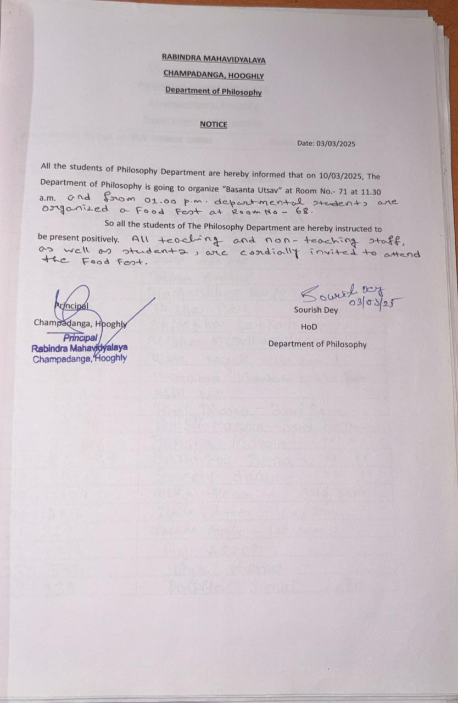

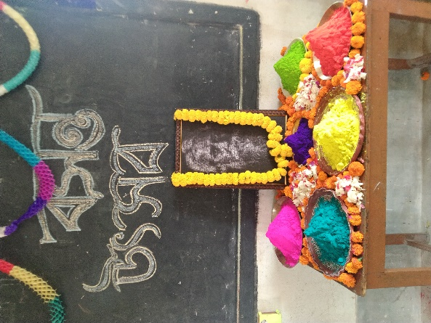
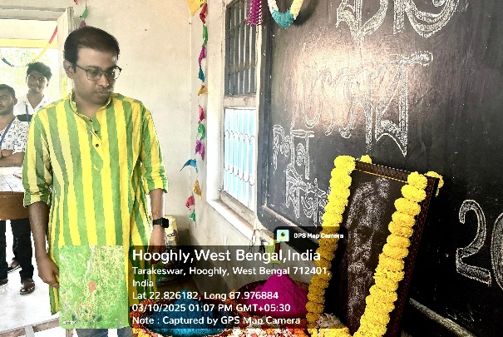
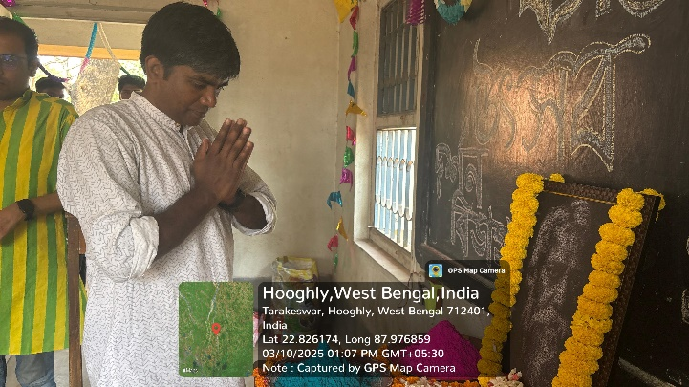
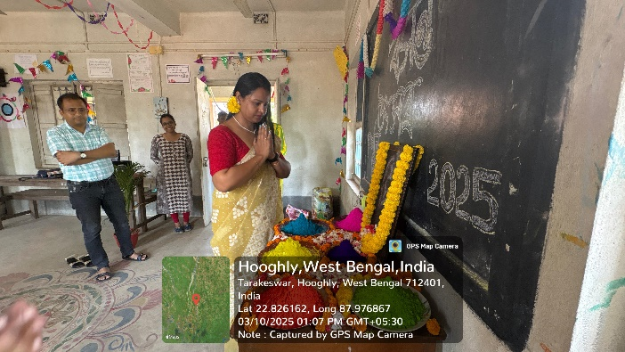
Inaugural session by the departmental professors
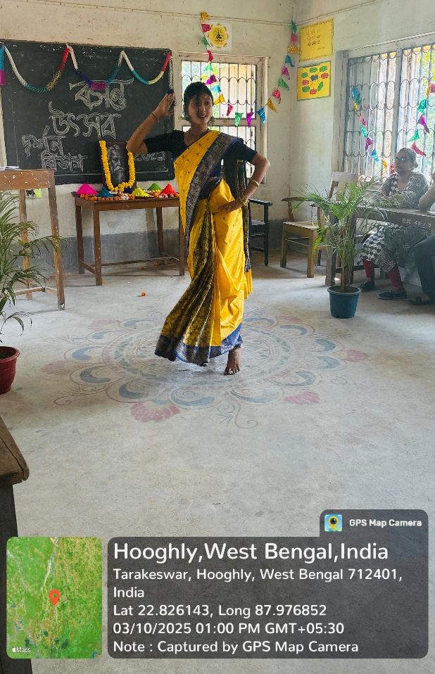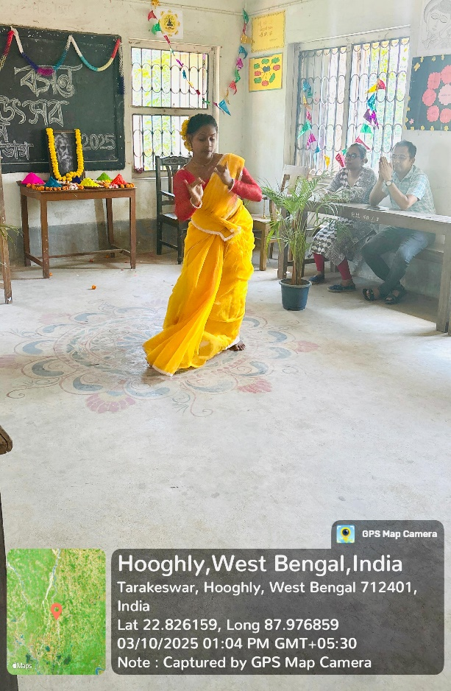
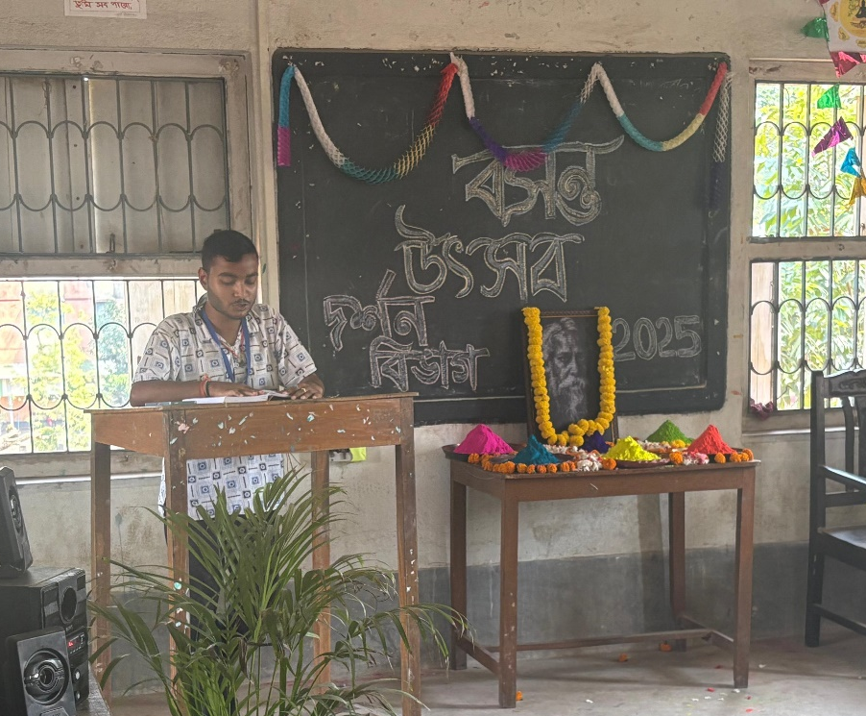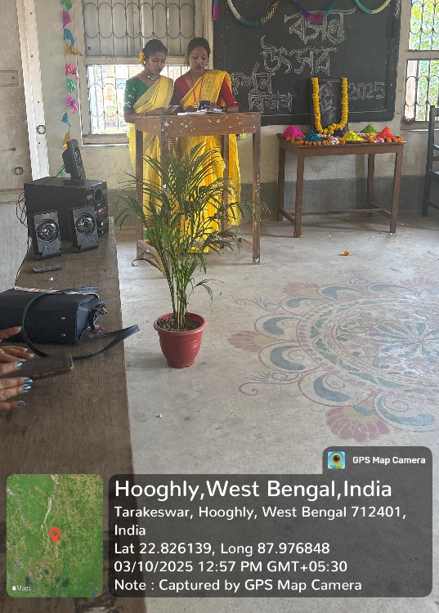
Coultural program by our students
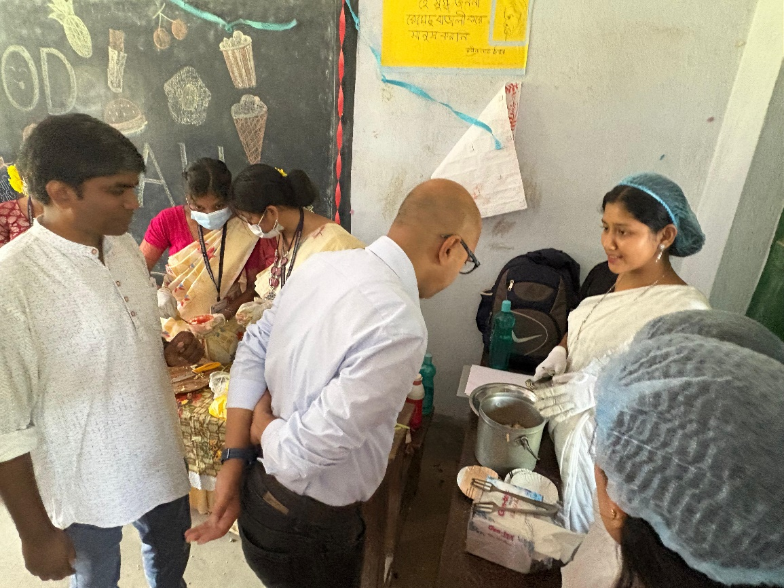
Visit Principal sir
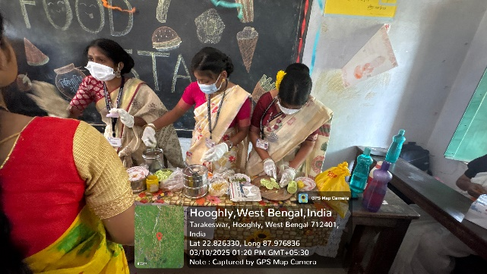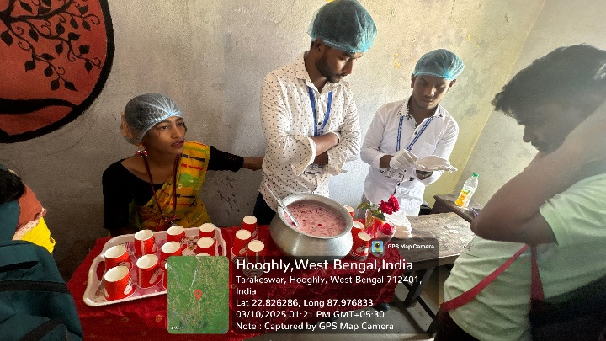
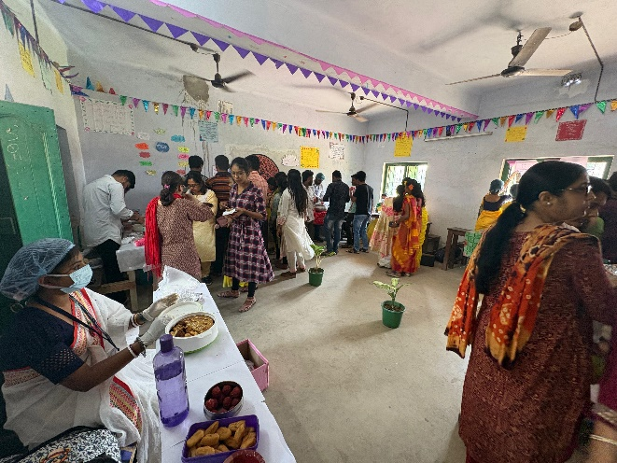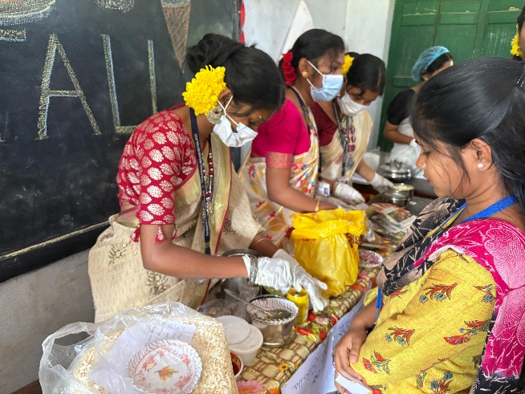
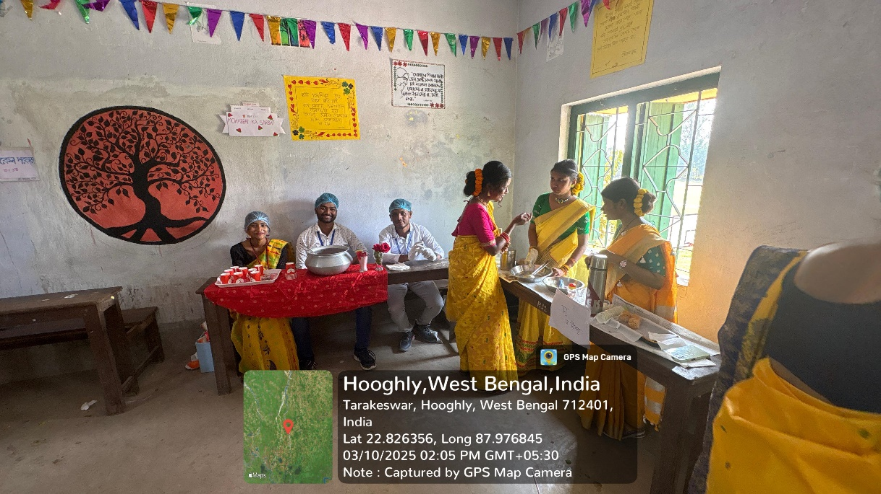
Food stall picture
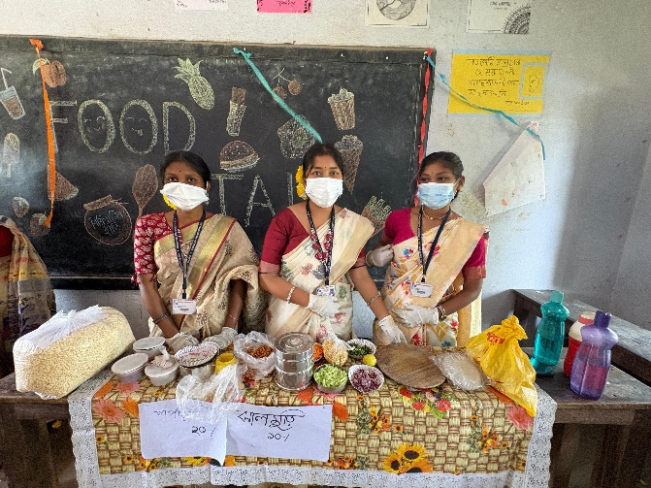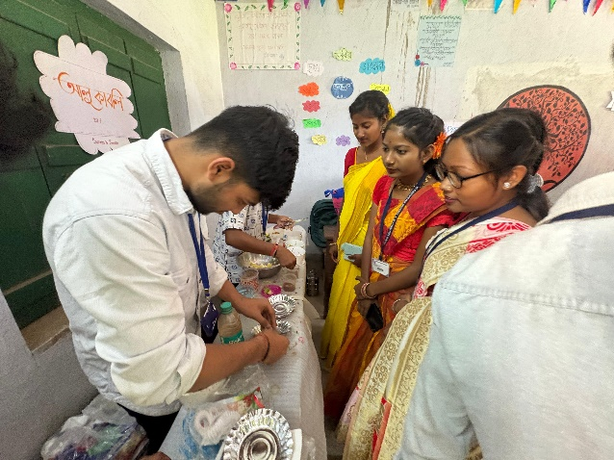
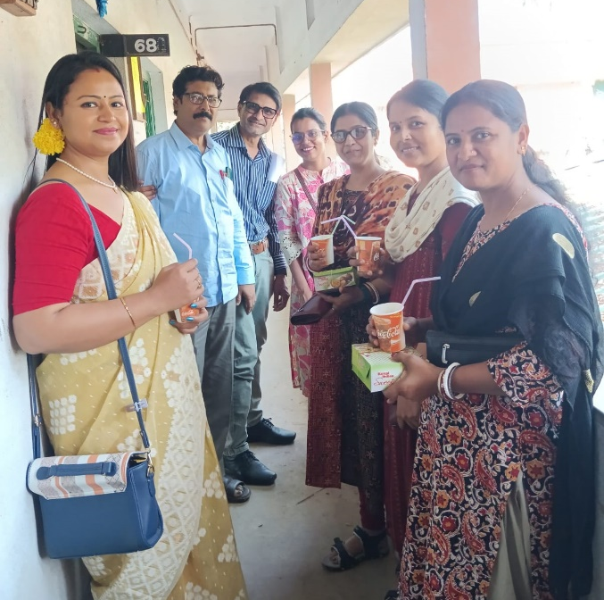
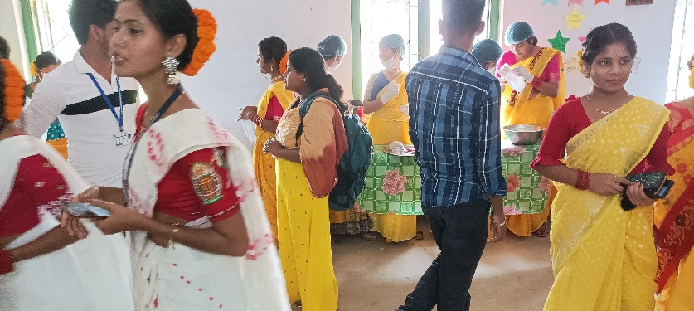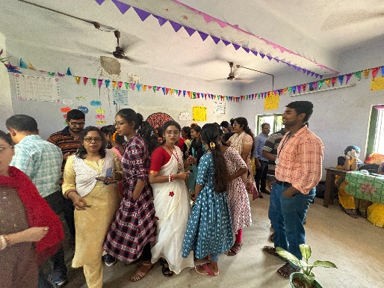

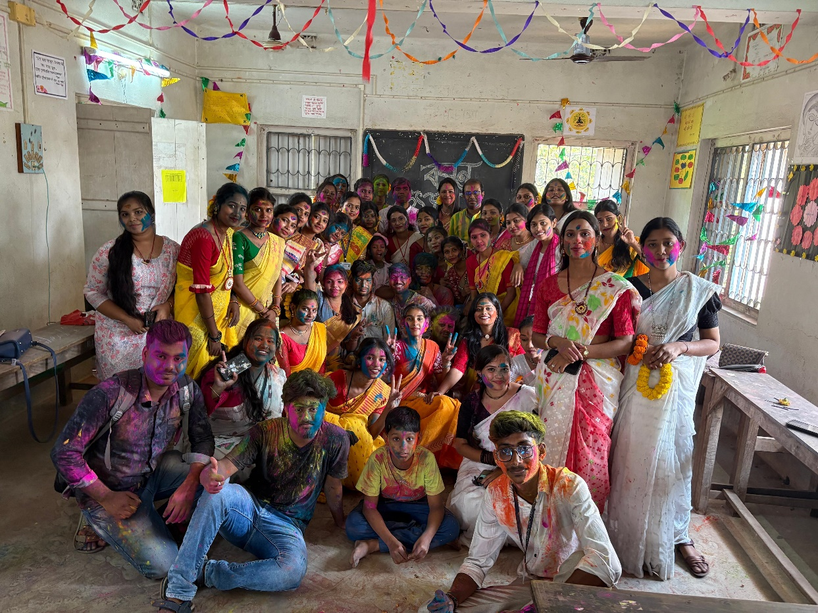
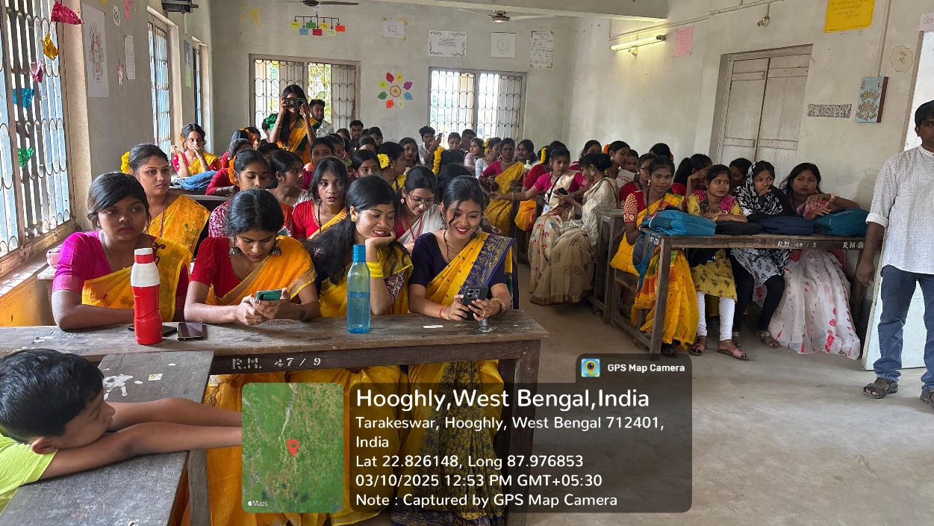
with the highest attendant students

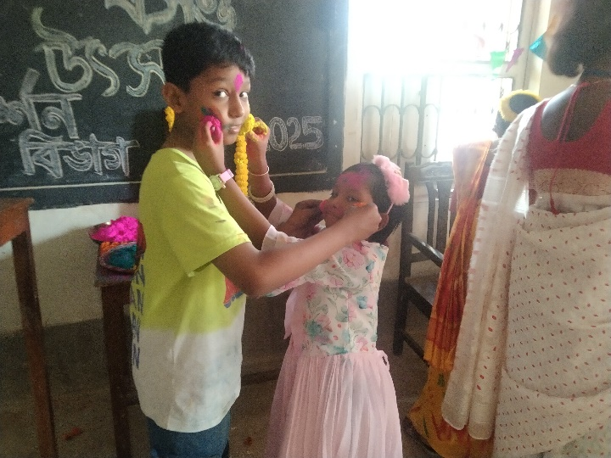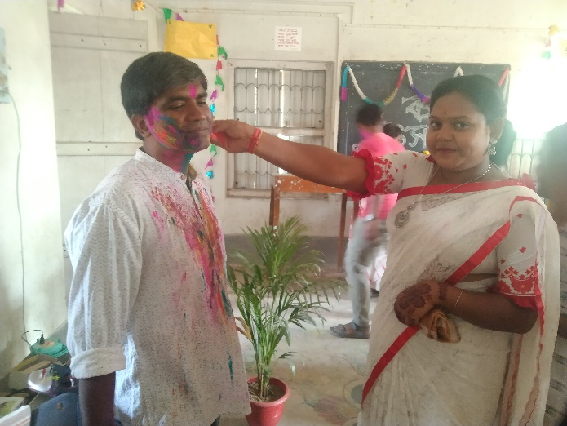
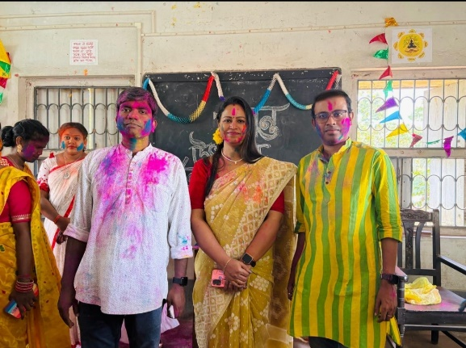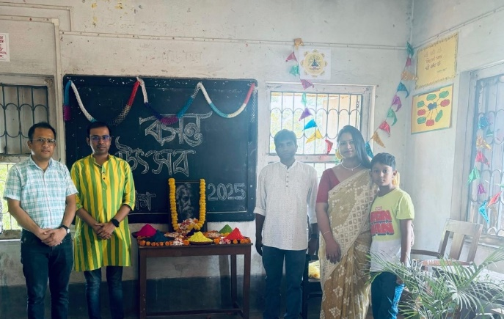
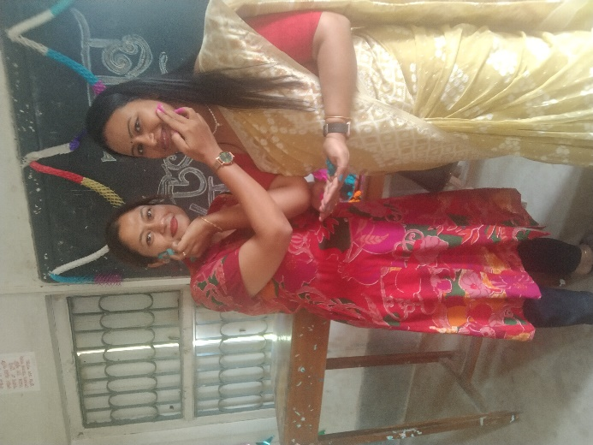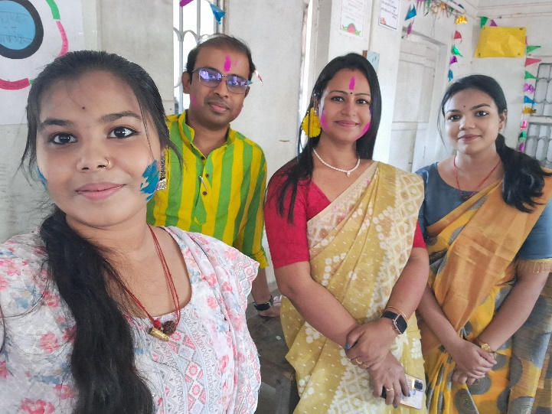
SOME GLIMPS

Attendence sheet
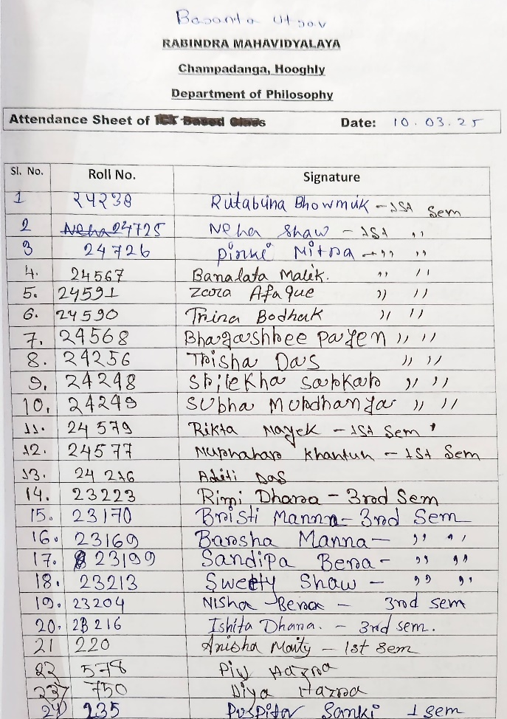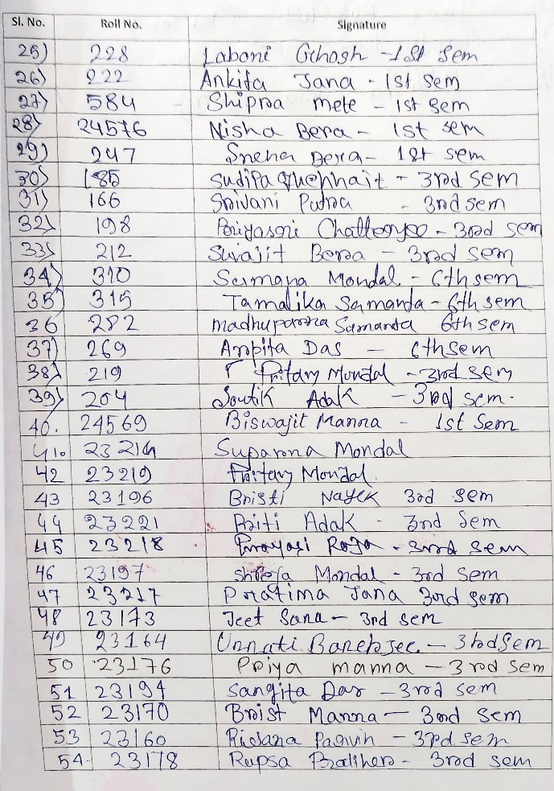

Attendance: 58
Male: 11
Female:47

Tentative programmed schedule:
- Food stall started: 11.30a.m. to 4.00p.m.
- Basanta utsab Inaugural session: 1.00 p.m. to 1.20p.m.
- Cultural programmed:1.45p.m. to 2.30 p.m.

Feedback Summary

- Maximum responses (80%) received.
- 95 % felt satisfactory.
- 90% opined the event helped to improve their moral values/thinking
- 95% people enjoy a lot to this event.

Some feedback
- Very encouraging and good initiative by the students, I enjoyed very much and wish to attend more in future. All students tried their best to serve their food to us. Only one stall prepared the food by their own hand. I am sure the students of this stall will rectify themselves in the next time. Another worth mentioning matter is that if the programmed would be arranged in the ground-floor corridor of the old administrative building, it would get more space and accommodate more people.
- Next time, the food stall should have a little more food.
- Please arrange this type of program biannual.

